Spark Learning:

When Spark Job initialized following operations will happen:

1. Creates no.of Executors
2. No.Of Jobs
   1. 1st Job: Read data from table
   2. 2nd Job: Count the data

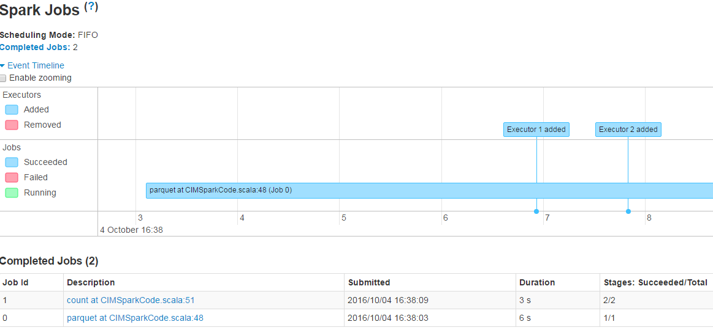

1st Job:

For each job, it creates Stages. Only 1 Stage is created.

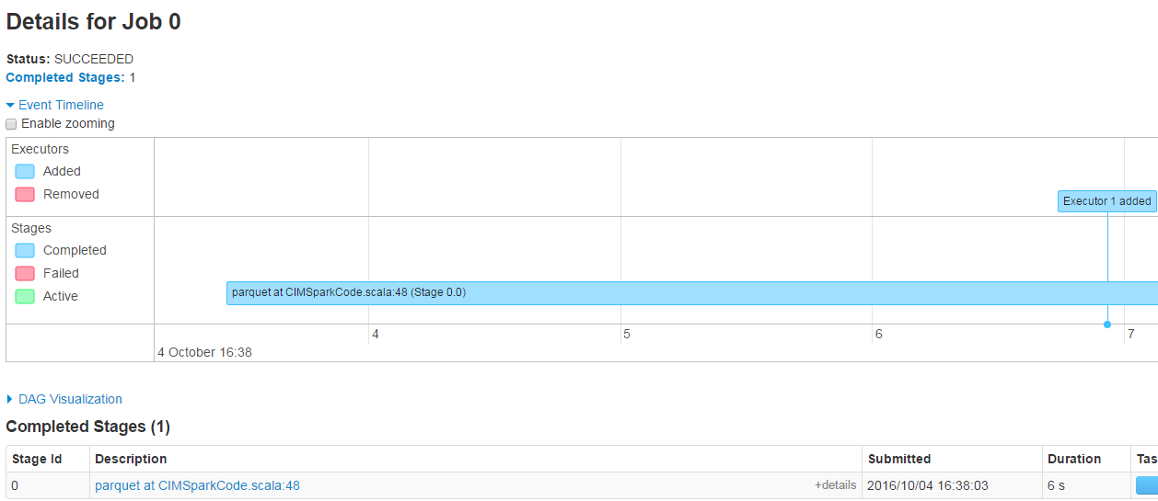

Stage:

For each stage, it creates Executor’s. Only 1 Executor Created.

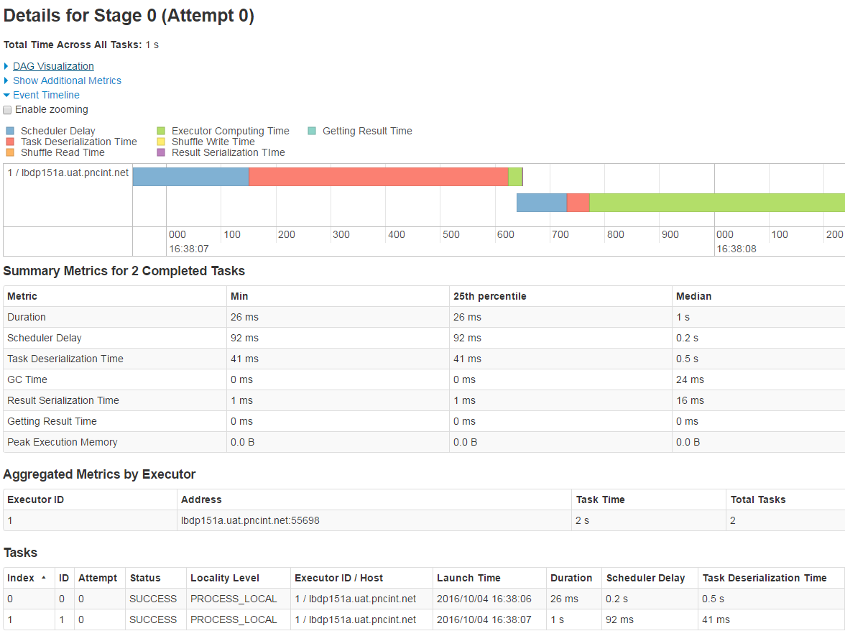

2nd Job:

It created 2 Stages for Count operation.

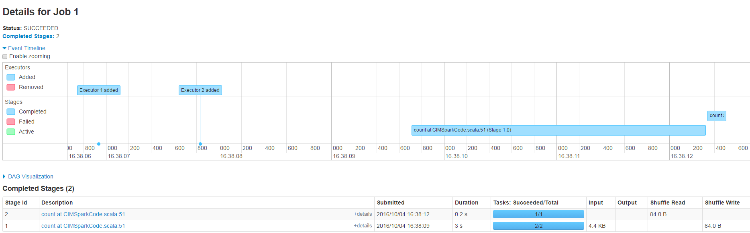

Stage 1:

There are 2 Executor’s are created. Each executor read data from Each Data Node.

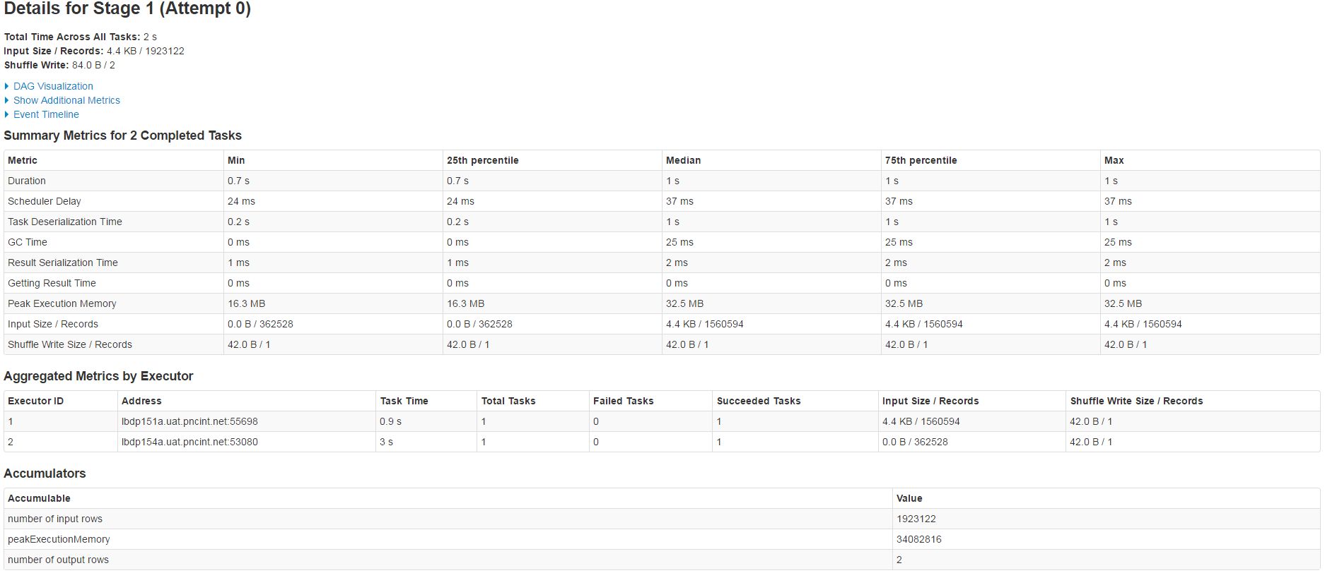

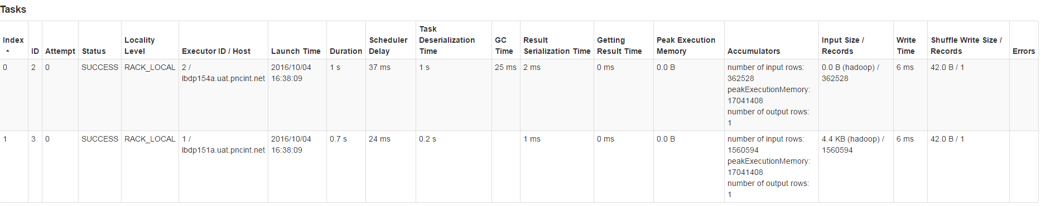

2nd Executor: Read Data from 1st Executor’s

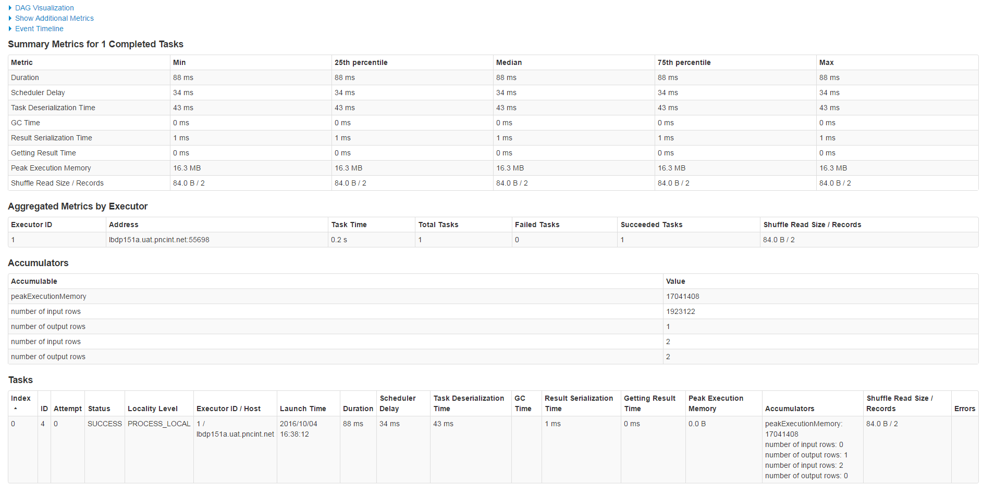

The following Spark Job reading data from 3 tables. Each table read data and count. And join 2 tables & count.

7 jobs are created.

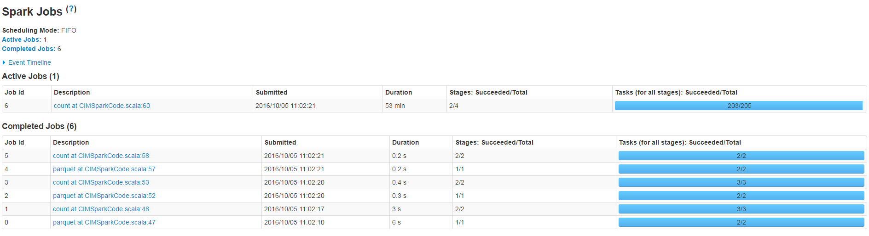

== Parsed Logical Plan ==

Aggregate [count(1) AS count#120L]

Join LeftOuter, Some((DATE_KEY#39 = DATE_KEY#99))

Relation[atm_hier_key#0,channel_key#1,cust_prospect_type_key#2,offer_key#3,location_key#4,agent_key#5,nbr_responses#6,nbr_accept_responses#7,nbr_decline_responses#8,nbr_maybe_later_responses#9,nbr_offers_presented#10,nbr_successful_responses#11,nbr_qualified_offers#12,nbr_qualified_offers_top_3#13,nbr_qualified_offers_nba#14,nbr_qualified_offers_pos_2#15,nbr_qualified_offers_pos_3#16,nbr_nba_presented#17,cif_key#18,cif_perm_key#19,session_id#20,offer_qualification_rank#21,offer_display_rank#22,nbr_control_group_offers#23,nbr_no_offer_offers#24,nbr_expedite_offers#25,card_number#26,nbr_qualified_offers_notofferd#27,sub_disposition_key#28,call_key#29,branch_id#30,employee_id#31,bank#32,disposition_key#33,device_key#34,business_segment_key#35,operating_system_key#36,created_date#37,hdfs_load_ts#38,date_key#39] ParquetRelation[hdfs://bdp-isilonuat01.uat.pncint.net:8020/bdpd/bdh/01/str/pub/bdhhd01d_bdh/cust_intractn_event_fact/date_key=20160822]

Relation[atm_hier_key#60,channel_key#61,cust_prospect_type_key#62,offer_key#63,location_key#64,agent_key#65,nbr_responses#66,nbr_accept_responses#67,nbr_decline_responses#68,nbr_maybe_later_responses#69,nbr_offers_presented#70,nbr_successful_responses#71,nbr_qualified_offers#72,nbr_qualified_offers_top_3#73,nbr_qualified_offers_nba#74,nbr_qualified_offers_pos_2#75,nbr_qualified_offers_pos_3#76,nbr_nba_presented#77,cif_key#78,cif_perm_key#79,session_id#80,offer_qualification_rank#81,offer_display_rank#82,nbr_control_group_offers#83,nbr_no_offer_offers#84,nbr_expedite_offers#85,card_number#86,nbr_qualified_offers_notofferd#87,sub_disposition_key#88,call_key#89,branch_id#90,employee_id#91,bank#92,disposition_key#93,device_key#94,business_segment_key#95,operating_system_key#96,created_date#97,hdfs_load_ts#98,date_key#99] ParquetRelation[hdfs://bdp-isilonuat01.uat.pncint.net:8020/bdpd/bdh/01/str/pub/bdhhd01d_bdh/cust_intractn_event_fact]

== Analyzed Logical Plan ==

count: bigint

Aggregate [count(1) AS count#120L]

Join LeftOuter, Some((DATE_KEY#39 = DATE_KEY#99))

Relation[atm_hier_key#0,channel_key#1,cust_prospect_type_key#2,offer_key#3,location_key#4,agent_key#5,nbr_responses#6,nbr_accept_responses#7,nbr_decline_responses#8,nbr_maybe_later_responses#9,nbr_offers_presented#10,nbr_successful_responses#11,nbr_qualified_offers#12,nbr_qualified_offers_top_3#13,nbr_qualified_offers_nba#14,nbr_qualified_offers_pos_2#15,nbr_qualified_offers_pos_3#16,nbr_nba_presented#17,cif_key#18,cif_perm_key#19,session_id#20,offer_qualification_rank#21,offer_display_rank#22,nbr_control_group_offers#23,nbr_no_offer_offers#24,nbr_expedite_offers#25,card_number#26,nbr_qualified_offers_notofferd#27,sub_disposition_key#28,call_key#29,branch_id#30,employee_id#31,bank#32,disposition_key#33,device_key#34,business_segment_key#35,operating_system_key#36,created_date#37,hdfs_load_ts#38,date_key#39] ParquetRelation[hdfs://bdp-isilonuat01.uat.pncint.net:8020/bdpd/bdh/01/str/pub/bdhhd01d_bdh/cust_intractn_event_fact/date_key=20160822]

Relation[atm_hier_key#60,channel_key#61,cust_prospect_type_key#62,offer_key#63,location_key#64,agent_key#65,nbr_responses#66,nbr_accept_responses#67,nbr_decline_responses#68,nbr_maybe_later_responses#69,nbr_offers_presented#70,nbr_successful_responses#71,nbr_qualified_offers#72,nbr_qualified_offers_top_3#73,nbr_qualified_offers_nba#74,nbr_qualified_offers_pos_2#75,nbr_qualified_offers_pos_3#76,nbr_nba_presented#77,cif_key#78,cif_perm_key#79,session_id#80,offer_qualification_rank#81,offer_display_rank#82,nbr_control_group_offers#83,nbr_no_offer_offers#84,nbr_expedite_offers#85,card_number#86,nbr_qualified_offers_notofferd#87,sub_disposition_key#88,call_key#89,branch_id#90,employee_id#91,bank#92,disposition_key#93,device_key#94,business_segment_key#95,operating_system_key#96,created_date#97,hdfs_load_ts#98,date_key#99] ParquetRelation[hdfs://bdp-isilonuat01.uat.pncint.net:8020/bdpd/bdh/01/str/pub/bdhhd01d_bdh/cust_intractn_event_fact]

== Optimized Logical Plan ==

Aggregate [count(1) AS count#120L]

Project

Join LeftOuter, Some((DATE_KEY#39 = DATE_KEY#99))

Project [DATE_KEY#39]

Relation[atm_hier_key#0,channel_key#1,cust_prospect_type_key#2,offer_key#3,location_key#4,agent_key#5,nbr_responses#6,nbr_accept_responses#7,nbr_decline_responses#8,nbr_maybe_later_responses#9,nbr_offers_presented#10,nbr_successful_responses#11,nbr_qualified_offers#12,nbr_qualified_offers_top_3#13,nbr_qualified_offers_nba#14,nbr_qualified_offers_pos_2#15,nbr_qualified_offers_pos_3#16,nbr_nba_presented#17,cif_key#18,cif_perm_key#19,session_id#20,offer_qualification_rank#21,offer_display_rank#22,nbr_control_group_offers#23,nbr_no_offer_offers#24,nbr_expedite_offers#25,card_number#26,nbr_qualified_offers_notofferd#27,sub_disposition_key#28,call_key#29,branch_id#30,employee_id#31,bank#32,disposition_key#33,device_key#34,business_segment_key#35,operating_system_key#36,created_date#37,hdfs_load_ts#38,date_key#39] ParquetRelation[hdfs://bdp-isilonuat01.uat.pncint.net:8020/bdpd/bdh/01/str/pub/bdhhd01d_bdh/cust_intractn_event_fact/date_key=20160822]

Project [DATE_KEY#99]

Relation[atm_hier_key#60,channel_key#61,cust_prospect_type_key#62,offer_key#63,location_key#64,agent_key#65,nbr_responses#66,nbr_accept_responses#67,nbr_decline_responses#68,nbr_maybe_later_responses#69,nbr_offers_presented#70,nbr_successful_responses#71,nbr_qualified_offers#72,nbr_qualified_offers_top_3#73,nbr_qualified_offers_nba#74,nbr_qualified_offers_pos_2#75,nbr_qualified_offers_pos_3#76,nbr_nba_presented#77,cif_key#78,cif_perm_key#79,session_id#80,offer_qualification_rank#81,offer_display_rank#82,nbr_control_group_offers#83,nbr_no_offer_offers#84,nbr_expedite_offers#85,card_number#86,nbr_qualified_offers_notofferd#87,sub_disposition_key#88,call_key#89,branch_id#90,employee_id#91,bank#92,disposition_key#93,device_key#94,business_segment_key#95,operating_system_key#96,created_date#97,hdfs_load_ts#98,date_key#99] ParquetRelation[hdfs://bdp-isilonuat01.uat.pncint.net:8020/bdpd/bdh/01/str/pub/bdhhd01d_bdh/cust_intractn_event_fact]

== Physical Plan ==

TungstenAggregate(key=[], functions=[(count(1),mode=Final,isDistinct=false)], output=[count#120L])

TungstenExchange SinglePartition

TungstenAggregate(key=[], functions=[(count(1),mode=Partial,isDistinct=false)], output=[currentCount#123L])

TungstenProject

SortMergeOuterJoin [DATE_KEY#39], [DATE_KEY#99], LeftOuter, None

TungstenSort [DATE_KEY#39 ASC], false, 0

TungstenExchange hashpartitioning(DATE_KEY#39)

ConvertToUnsafe

Scan ParquetRelation[hdfs://bdp-isilonuat01.uat.pncint.net:8020/bdpd/bdh/01/str/pub/bdhhd01d_bdh/cust_intractn_event_fact/date_key=20160822][DATE_KEY#39]

TungstenSort [DATE_KEY#99 ASC], false, 0

TungstenExchange hashpartitioning(DATE_KEY#99)

ConvertToUnsafe

Scan ParquetRelation[hdfs://bdp-isilonuat01.uat.pncint.net:8020/bdpd/bdh/01/str/pub/bdhhd01d_bdh/cust_intractn_event_fact][DATE_KEY#99]